Introduction
Wavelet analysis is a modern and popular method of data analysis. Applications of this method are surprisingly wide: from seismology through cardiology, it ends up with digital image compression. Wavelet signal analysis provides information in both: time and frequency domains [3]. Of course the two–dimensional analysis of one dimensional data set must be redundant, but the additional information we obtain, is the argument for wide application of this method [4].
Wavelet analysis can be used to analyze EPR spectra, recorded as 1st derivative of paramagnetic absorption. Practically it leads to focusing on the components of specified shape and width in the spectrum.
Wavelet analysis in EPR spectroscopy
Adam Drzewiecki Paweł B. Sczaniecki
Institute of Physics,
University of Zielona Góra
ul. Szafrana 4a, 65-516 Zielona Góra
Wavelet analysis – basics
The wavelet transformation is defined as follows:
$Ψ\left(t,s\right)=\int_{−∞}^{∞}{f\left(x\right)}\frac{1}{\sqrt{s}}ϕ\left(\frac{x−t}{s}\right)\text{dx}$where f(x) is the analyzed function, φ is function called base wavelet, and t and s are parameters, controlling the processes called translation and scaling, respectively. Interpretation of this integral is simple: the obtained value is a measure of similarity of function f(x) and function φ, translated t units to the right on x–axis and then stretched s times. Both functions f(x) and φ must be square integrable.

Wavelet analysis with Lorentzian base wavelet
$ϕ\left(\frac{x−t}{s}\right)=−\frac{4}{\sqrt{π}}\frac{\frac{x−t}{s}}{{\left[1+{\left(\frac{x−t}{s}\right)}^{2}\right]}^{2}}$With the choice of normalized Lorentzian wavelet
$Ψ\left(t,s\right)=\int_{−∞}^{∞}{f_{A,B_{0},ΔB}^{'}{\left(x\right)}_{L}}\frac{1}{\sqrt{s}}ϕ\left(\frac{x−t}{s}\right)\text{dx}=−\frac{4A\sqrt{π}Δ{\text{Bs}}^{\frac{3}{2}}}{{\left(s+ΔB\right)}^{3}}\frac{3{\left(\frac{t−B_{0}}{s+ΔB}\right)}^{2}−1}{{\left[{\left(\frac{t−B_{0}}{s+ΔB}\right)}^{2}+1\right]}^{3}}$the wavelet transformation of one Lorentzian derivative has the form

Function has one maximum at (t=B₀, s=ΔB).
Visualization of single EPR line wavelet analysis
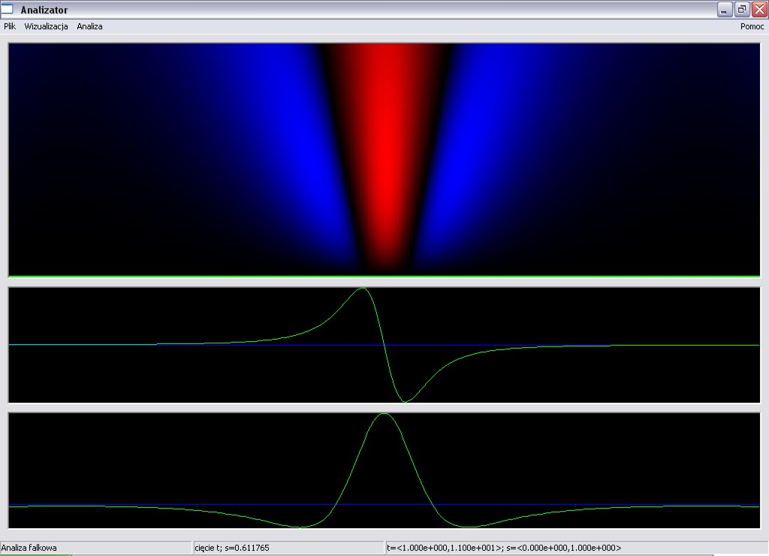
In the picture the patterns from left to right correspond to negative-positive-negative values.
Wavelet analysis–an example
Guanidinium aluminium sulphate hexahydrate is a ferroelectric with space space group C²_{3v} (P31m). The crystal formula is
$C({\text{NH}}_{2})_{3}\text{Al}{\left(H_{2}O\right)}_{6}{\left({\text{SO}}_{4}\right)}_{2}$three nearly planar guanidinium groups are sandwiched between the hexaquo–metal octahedral [1]. Exposing the crystal to X–ray K_{α} radiation for 2 hours produces paramagnetic, anisotropic centers whose EPR will be used as an example of the application of the wavelet analysis. Three overlapping components can be distinguished, all in the vicinity of free radical g-value [2].
Recorded EPR spectrum
Wavelet analysis of the EPR spectrum
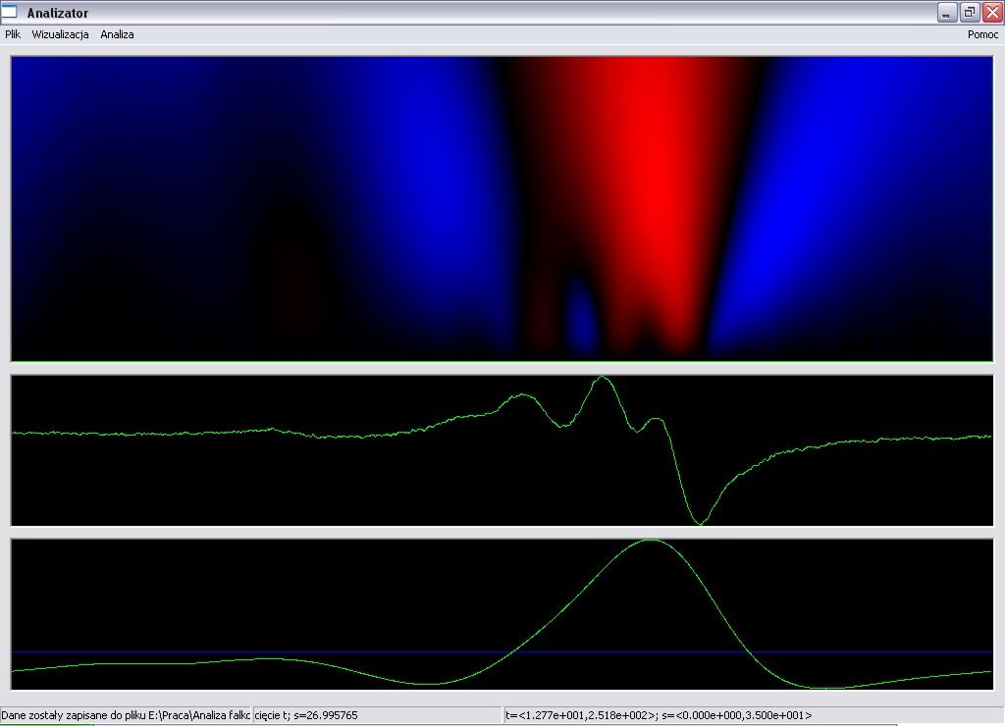
Analysis reveals the existence of the broad line (the maximum of the analysis at large value of s), to be removed from the spectrum before the further analysis.
Analysis of the reduced spectrum
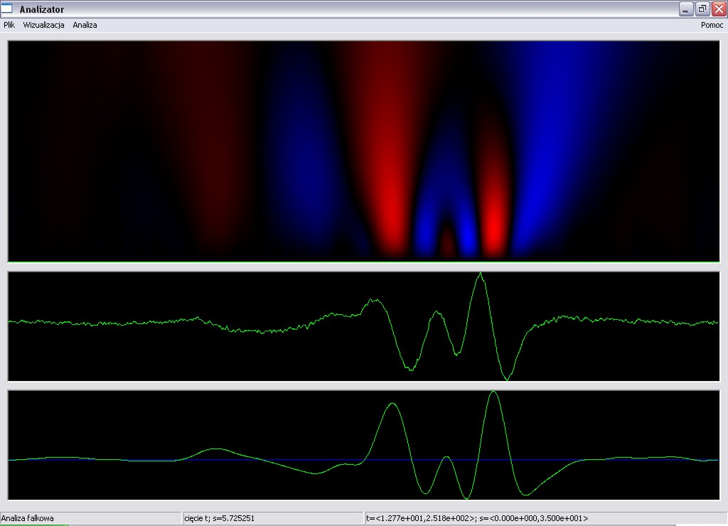
Analysis of the reduced spectrum shows two relatively narrow lines (it occurs at the maxima of the analysis at small values of s)
Synthesis of the complex EPR spectrum
Results and discussion
The set of the parameters resulting from the analysis is:
An attempt has been made to synthesize the original EPR spectrum from the obtained parameters. One may conclude that the wavelet analysis is a complementary tool for spectra interpretation; the synthesized spectrum resembles the experimental observation. As an additional utility one has the option of searching and eliminating unwanted features from the experimental data.
References
[1] B. J. B. Schein, E. C. Lingafelter and J. M. Stewart, J. Chem. Phys. 47, 5138 (1967)
[2] P. B. Sczaniecki, B. Jakubaszek, L. Szczepańska, Magnetic Resonance and Related Phenomena, Proc. 29AMPERE/13 ISMAR International Conference, Berlin 1998, p. 981
[3] D. B. Percival, A. T. Walden, Wavelet methods for time series analysis, Cambridge University Press, Cambridge 2000
[4] J. T. Białasiewicz, Falki i aproksymacje, Wydawnictwo Naukowo-Techniczne, Warszawa 2004, p. 66 (in Polish)

